Vector Practice Lab

Deliverables & Notes:
This is a list of the stuff you should turn in to G/Q. will staple them together for your group.
- This lab Sheet
  - It is important to us that ALL group members work collaboratively. Everyone should have something written down in every question, even if it isn’t the final answer for your group. This helps us to make sure everyone is working hard, we have evidence of your contributions (especially since we are out), and to see what things we may need to review in future lessons.
  - The answer sheet with the combined group answers should be the first of the four sheets and have a star★ at the top. This will let us know that this is the one you want graded for accuracy. The rest of the sheets will be checked for completion/effort.

Part A: Short Answer

Be short and concise! Less is more! Seriously, we only look for key words. Save time for the other questions
- Very briefly, describe the Tip-to-Tail method. [3 points]

- What does the commutative property let us do with vector addition? [3 points]

Part C: Application Question (***do this question last***)

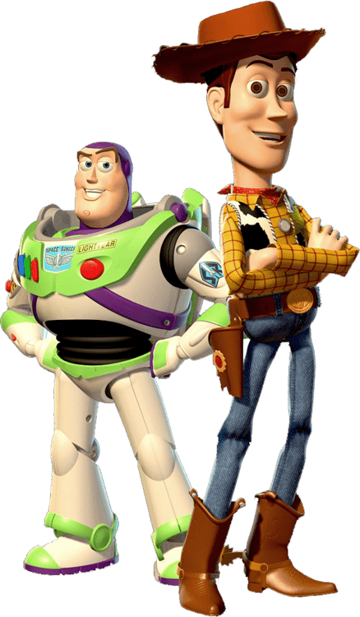
Buzz and Woody are trying to find their way through Pizza Planet to be reunited with Andy. They have to sneak around all of the people, so they aren’t discovered. Read the following set of movements, then use the combined knowledge of your lab group to solve the following complex problem. [22 points total]

Our heroes begin by running 90 m north. They then turn 55º |/ east of north and run 65 m. They hide behind a barrel at that spot while they wait for some kids to pass. They then run 50 m directly east. They take a short break inside “the claw!” machine. After almost being captured by Sid, they then travel 50 m at 30º south of east. Finally, they run for 15 m at an angle that is 17º /| west of south before jumping into Andy’s backpack.

Use and loose-leaf paper if needed, to do the following:
- Create a diagram that depicts the scenario. You are encouraged to use a ruler (with a scale of 10m=1cm if you know how) and a protractor. This will help you keep your lines straight and your directions precise. Please include a symbol at the start and at the end. If you have time at the end, add interesting illustrations to turn up to 3 points back on other questions. [7 points]
- Find the total distance traveled by the toys during the chase. [3 points]
- If all of the movements took 73 s to transpire, what was their average speed from start to finish. [3 points]
- Here’s the tough one. What is their total displacement vector? For full points, find the magnitude of this vector and find its direction/angle. Show all of your steps/calculations. [5 points]
- Lastly, what is their velocity vector. For full points find the magnitude of this vector and its direction/angle. Show all of your steps/calculations. [4 points]

Part B: Draw the Vectors

Use the Tip-to-Tail method to show the following Vector Addition or Subtraction by drawing the resultant vectors using a dotted line with an arrowhead and label it as “ $\overset{⃑}{r}$”. If there is no resultant, write “NONE”. Start $\overset{⃑}{a}$ at the dot “•” so you have enough room. Use a straight edge, like your ID card, to be as neat as possible. [2 point each, 22 points total]
$$\overset{⃑}{d}$$
$$\overset{⃑}{c}$$
$$\overset{⃑}{b}$$
$$\overset{⃑}{a}$$
$$\overset{⃑}{a}$$
$$\overset{⃑}{a}$$
$$\overset{⃑}{c}$$
$$\overset{⃑}{b}$$
$$\overset{⃑}{d}$$
$$\overset{⃑}{a}$$
$$\overset{⃑}{a}$$
$$\overset{⃑}{a}$$
$$\overset{⃑}{a}$$
$$\overset{⃑}{a}$$
$$\overset{⃑}{a}$$
$$\overset{⃑}{a}$$

EXAMPLE: $\overset{⃑}{a}+ \overset{⃑}{b}= \overset{⃑}{r}$  $$\overset{⃑}{b}$$  $$\overset{⃑}{r}$$ | $$\overset{⃑}{b}$$  $$\overset{⃑}{a}$$ | - $\overset{⃑}{a}+ \overset{⃑}{b}= \overset{⃑}{r}$
- $\overset{⃑}{a}- \overset{⃑}{b}= \overset{⃑}{r}$ | $$\overset{⃑}{b}$$ | - $-\overset{⃑}{a}+ \overset{⃑}{b}= \overset{⃑}{r}$ | $$\overset{⃑}{b}$$
- $-\overset{⃑}{a}+ \overset{⃑}{b}= \overset{⃑}{r}$ | $$\overset{⃑}{b}$$ | - $\overset{⃑}{a}- \overset{⃑}{b}= \overset{⃑}{r}$ | $$\overset{⃑}{b}$$
- $\overset{⃑}{a}+ \overset{⃑}{b}= \overset{⃑}{r}$ | $$\overset{⃑}{a}$$  $$\overset{⃑}{c}$$  $$\overset{⃑}{b}$$ | - $\overset{⃑}{a}- \overset{⃑}{b}- \overset{⃑}{c}= \overset{⃑}{r}$ | $$\overset{⃑}{b}$$  $$\overset{⃑}{b}$$
- $\overset{⃑}{a}- \overset{⃑}{b}= \overset{⃑}{r}$ | $$\overset{⃑}{a}$$  $$\overset{⃑}{b}$$  $$\overset{⃑}{c}$$ | - $-\overset{⃑}{a}+ \overset{⃑}{b}+\overset{⃑}{c}= \overset{⃑}{r}$
- $\overset{⃑}{a}+ \overset{⃑}{b}+\overset{⃑}{c}+\overset{⃑}{d}= \overset{⃑}{r}$ |  | - $\overset{⃑}{a}+ \overset{⃑}{b}-\overset{⃑}{c}-\overset{⃑}{d}= \overset{⃑}{r}$ | $$\overset{⃑}{b}$$

